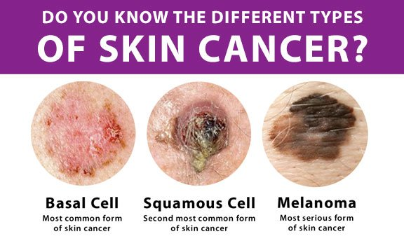 Skin Cancer is the most common type of cancer in the Unites States. It is a growth of abnormal cells, and in most cases, is caused by ultraviolet rays from the sun. There are three types: Basal cell carcinoma-the most common that usually grows on exposed areas to the sun. The face, neck, ears, and arms are most at risk. The prognosis is excellent for this type as it rarely spreads to other parts of the body. Squamous cell carcinoma- Slow growing and when caught early, easy to treat. Usually occurs above the shoulders on the neck, face, or scalp but can also be present in mouth, throat or lungs. A dental exam can be the first step in discovery because there are little to no symptoms present in the beginning stages. Melanoma- most dangerous type. It grows quickly and can spread to other organs. It is highly curable if found in the beginning stages so regular skin checks are crucial. 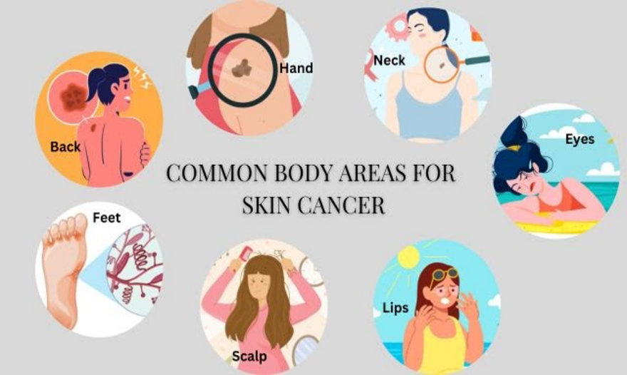Anyone can develop skin cancer, but you are more at risk if you are fair skinned, have red hair or freckles, have a family history, spend a lot of time outdoors, or use tanning beds. The best defense is taking preventative measures to stay safe. Wearing protective clothing, staying in the shade, and avoiding hours when the sun is the strongest ( 11a-3pm) is recommended. 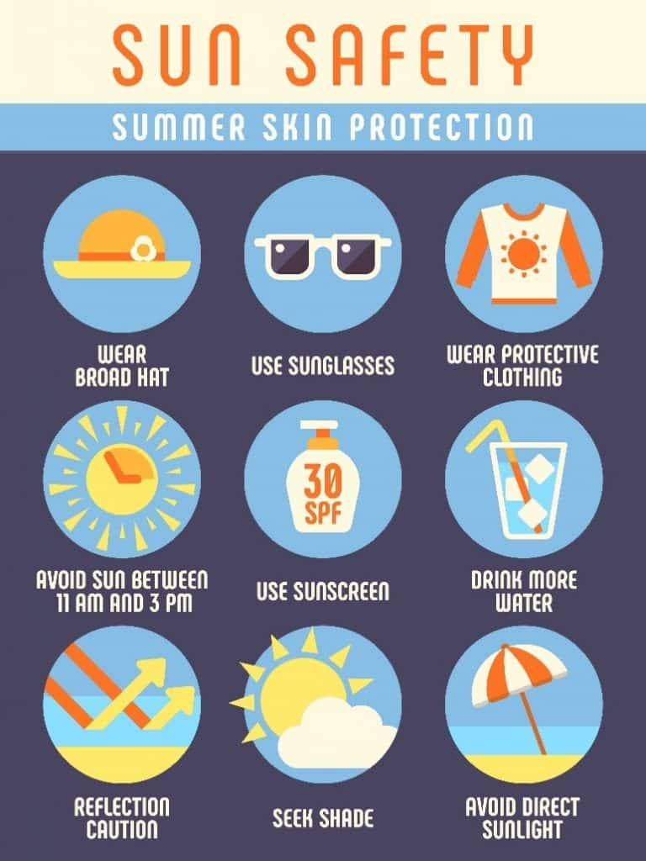 If you notice an abnormal growth, new mole or any skin changes contact your doctor or a dermatologist. A tool for determining if a mole is cancer is the ABCDE rule. 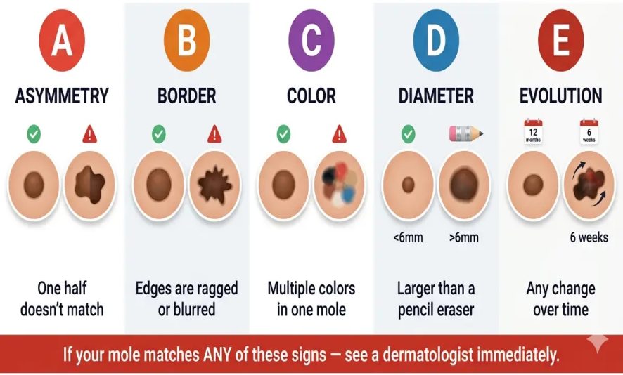There are several treatment options available. The most important is early detection and diagnosis to prevent spreading to other parts of the body.

