FREE HEALTH AND WELLNESS EDUCATION
Tick Education: Don’t get Sick From a Tick
SEPTEMBER 2026 WELLNESS SERIES
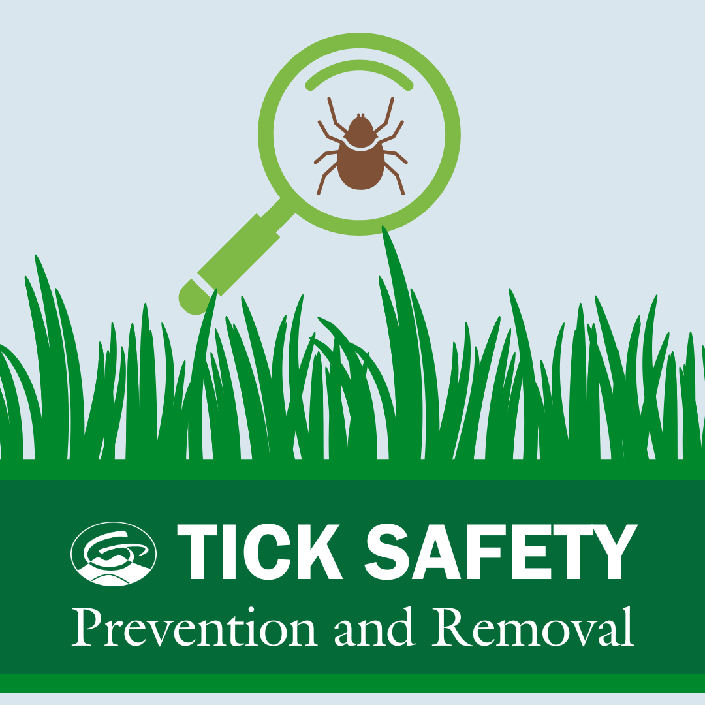
Ticks are small insects that are active in warmer months, usually from April through September. This informative workshop is designed to help you identify the types of ticks in our area, what symptoms to watch for if you are exposed to a tick bite, how to take preventative steps to reduce your exposure, and a quick demonstration on how to properly remove a tick from your skin. Whether you're hiking, gardening, or just spending time outside, ticks are everywhere. Please join us for this important seminar to help you reduce your risk of getting sick from a tick 

